8) Using a variety sets of software to assist in testing our application, we were able test everything from unit to acceptance. Even though 100% of our code was not tested, we were able to test a sufficient amount and that it is ready for demonstration.

The following is the list of software applications that were used to assist in debugging this software

NUnit:

We used we NUnit to unit test our software as much as possible. We had a basic idea how to approach unit testing, however, according to our McCabe results, the amount that would be needed to test would be too much for the short period of time. However, we wrote some of the unit testing to demonstrate how we would approach this. It was decided to focus more on the overall system than the individual components itself.

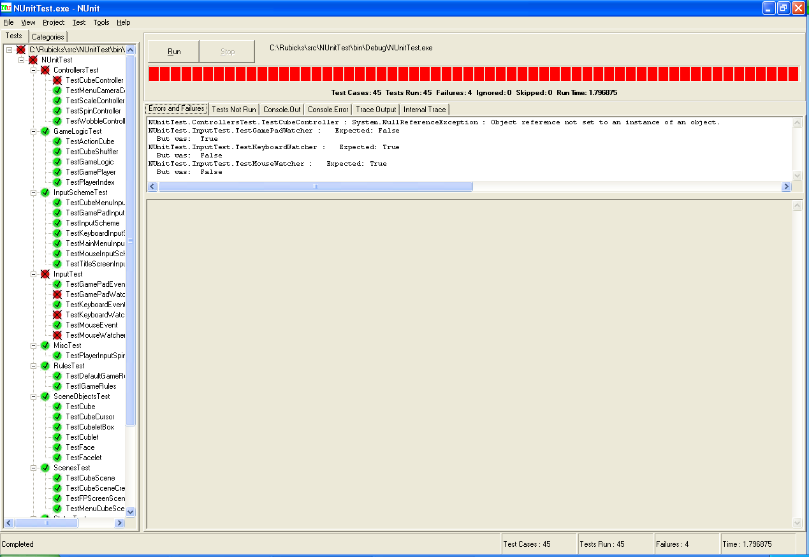

Other tests would cover more of the code in less time than unit testing could have.

Mantis Bug Tracker:

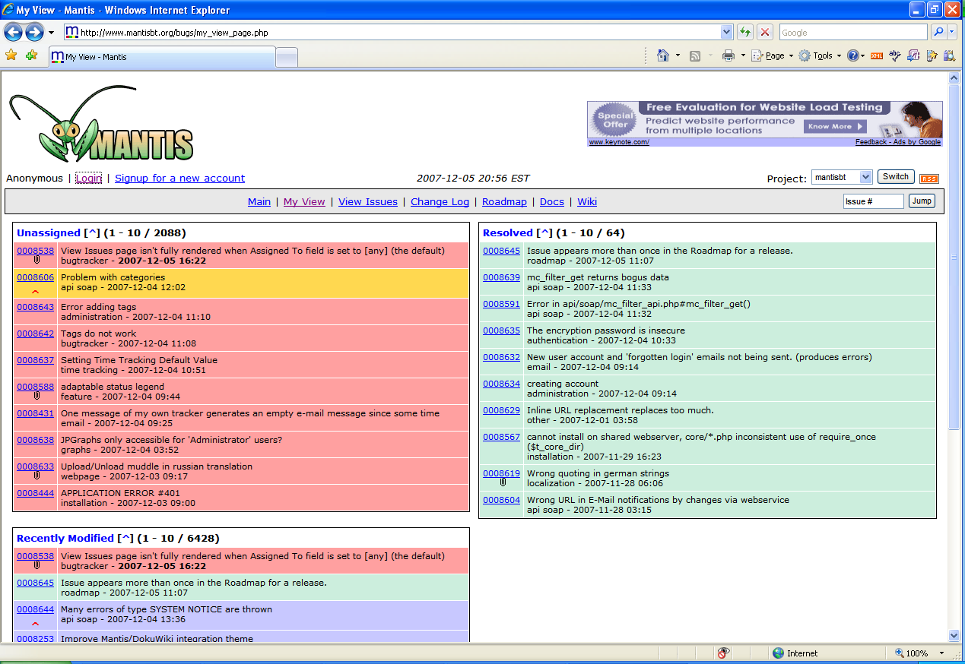

Mantis Bug Tracker was used to input a bug when discovered. It allowed us to assign these bugs to members of the team and to note when an item has be resolved.

<http://www.mantisbt.org/>

TestLog:

This allowed us to input the use cases of our software to be used for testing. It also allowed proper guidelines for testing and easy reporting of the results. We have entered 38 use cases and tested them at least twice a piece.

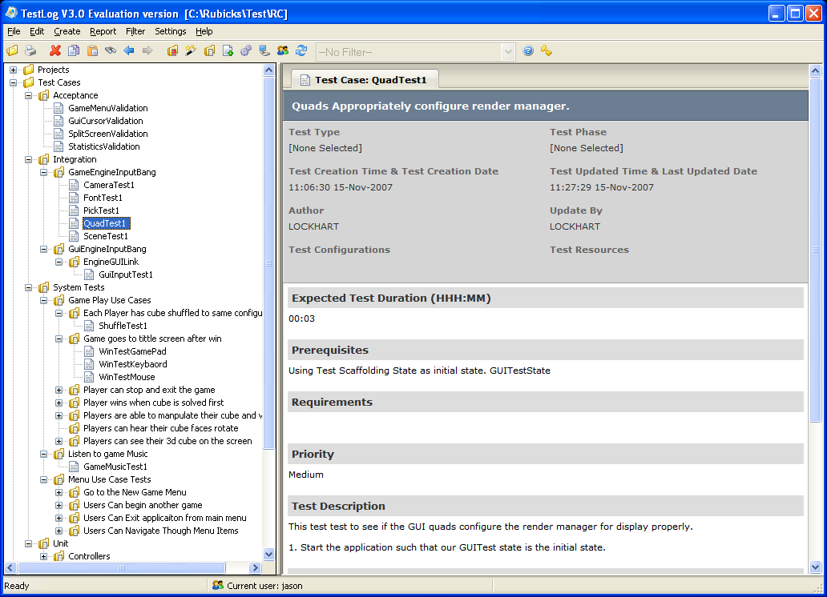

NCover:

Lastly, attempting to find coverage of our tests, we used this software that reports the coverage of the tests. NCover will run in the background of our program and keep track of where the program goes in the code itself. It became very useful in the sense of testing our code and as much of it as possible.

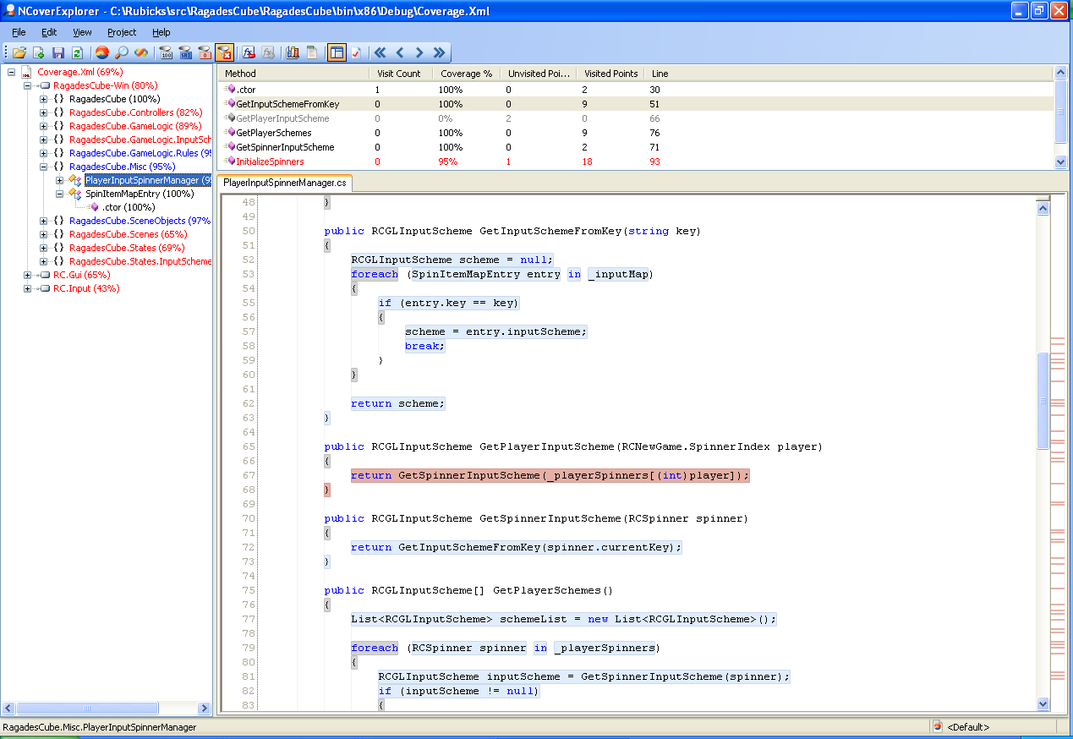

A report summarizing the coverage of our testing can be found here.

[NCover Results\index.html](NCover%20Results/index.html)

9)

Our summarization of work into this project is placed in the excel file pointed by this link.

[Work Log](WorkMetric.xlsx)